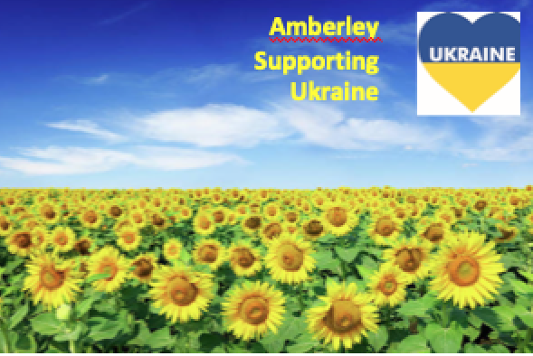
Dear Friends and Neighbours,
There have already been some great initiatives in our community to help Ukrainian refugees by sending supplies etc.
Now that the Government has agreed to take refugees in the UK there are many of us who are wondering how this will work and how we can offer to help - whether by offering spare rooms, rental accommodation or in other ways.
Clare Attard, Hazel Allinson and I met on Monday 14th March to discuss this and to co-ordinate local efforts.
We now know that you can register interest in providing accommodation at:
https://homesforukraine.campaign.gov.uk
You can register either as an individual (if you are offering rooms in your home) or an organisation (if for example you have a business that can offer accommodation or are a landlord with flats).
At present it still seems as if it will be necessary for there to be a named Ukrainian individual to whom the accommodation will be offered. But it no longer seems to be a condition of entry they have relatives already in the UK. The Government is working with two main charities, the Sanctuary Foundation and ‘Reset’ (an established refugee support organisation) and it looks like these two charities will be central to making the connections between UK individuals and Ukrainians who wish to come here. That ‘matching’ operation is not yet active as I write this (16th March) but is promised soon.
If you do register as above, we’d be grateful if you could let us know. Then we can make sure that arrivals (and host families) are given whatever support we can muster - for example, they may arrive with very few personal possessions, and we have offers of help with language skills and form filling etc.
If you can’t offer accommodation but would like to help in other ways, again could you please let us know.
We are also keeping in touch with other local organisations to see if we can pool resources:
Hazel (who is on Amberley Parish Council) will contact other local Parish Councils.
Mel (a churchwarden at St Michael’s Amberley) will contact the church councils (PCCs) of the other Wildbrooks Parishes (Parham, Wiggonholt and Greatham) and also Storrington and Thakeham.
Clare will keep in touch with any other individuals who aren’t reached via the above two routes.
Please could you also pass this information to anyone who you think would be interested. The information will also be in the next edition of the Wildbrooks Magazine.
Of course, if you would rather ‘do your own thing’ that fine too, we’re just offering to help if we can.
Kind Regards
Clare Attard: clare.attard@btinternet.com
Hazel Allinson: hazel.allinson@btinternet.com
Mel Edge: amberleystmichael@gmail.com

